EXPERIMENT-8

Name: Anirudh R Rollno:240701039

To create a storyboard representing the user flow of an application using Balsamiq by designing a low-fidelity prototype.

The Spotify app is designed to make it easy for users to find and enjoy music. Users can search for their favorite songs, explore artists and albums, view song details, and play music anytime. They can also create playlists, add songs to them, and manage their personal music library. The storyboard shows the complete flow of how a user interacts with the app, starting from logging in to discovering music, playing songs, and organizing their playlists

- Login / Sign Up Screen
- This is the first screen the user sees when opening the app.
- The user can enter their email and password to log in.
- There is also an option to sign up if the user is new.
- After logging in, the user is taken to the home screen.
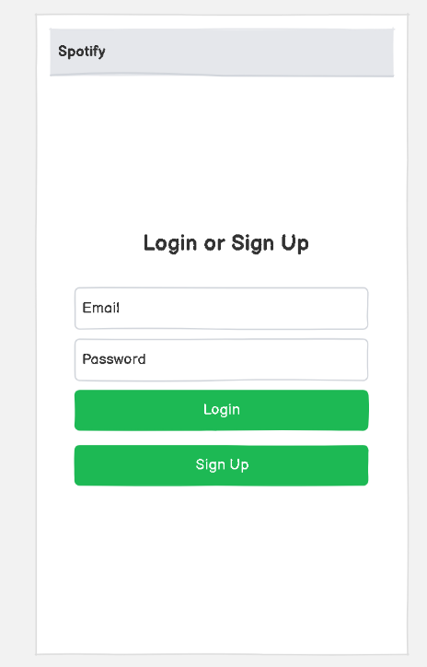

2. Home Screen
- This is the main screen of the app.
- It greets the user (e.g., “Good Morning”).
- The user can see recommended playlists like Workout Mix and Focus Playlist.
- It shows recently played songs such as Shape of You, Starboy, and Baby.

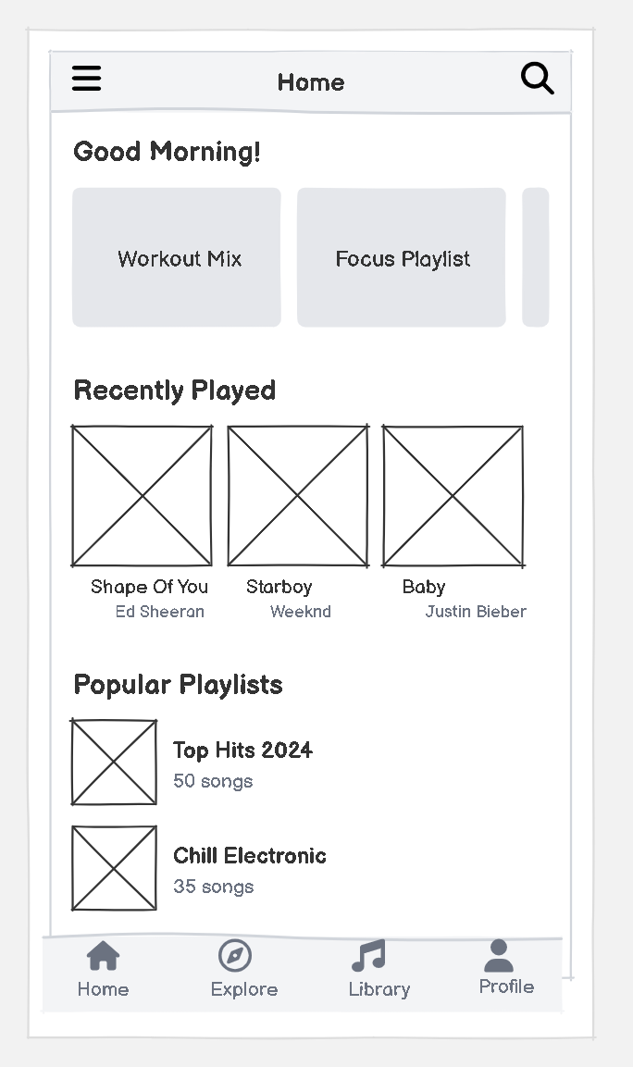

3. Now Playing Screen
- This screen appears when a song is played.
- It shows the song title and artist name.
- The user can play, pause, skip, or go back to songs.
- There is a progress bar to track the song

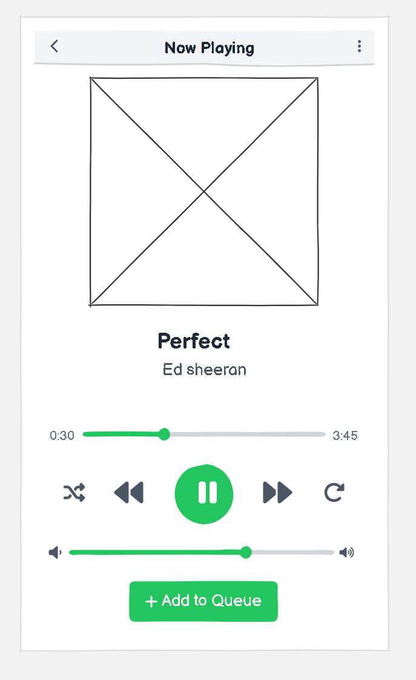

4. Queue Screen
- This screen shows the list of songs that will play next.
- The user can see multiple songs like Baby, Shape of You, Starboy, etc.
- Each song shows the title and artist name.
- The user can reorder songs in the queue.
